**Operation Analytics and Investigating Metric Spike**

1. **Jobs Reviewed Over Time:**
   * **Objective: Calculate the number of jobs reviewed per hour for each day in November 2020.**
   * **Your Task: Write an SQL query to calculate the number of jobs reviewed per hour for each day in November 2020.**

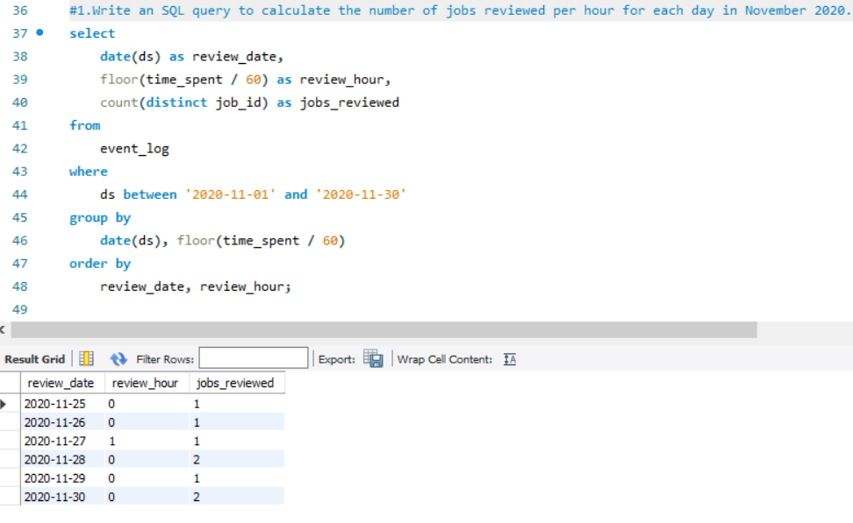

**B.Throughput Analysis:**

* + Objective: Calculate the 7-day rolling average of throughput (number of events per second).
  + Your Task: Write an SQL query to calculate the 7-day rolling average of throughput. Additionally, explain whether you prefer using the daily metric or the 7-day rolling average for throughput, and why.

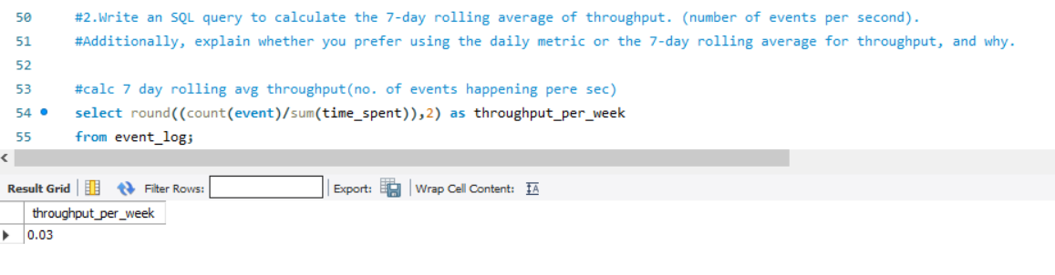

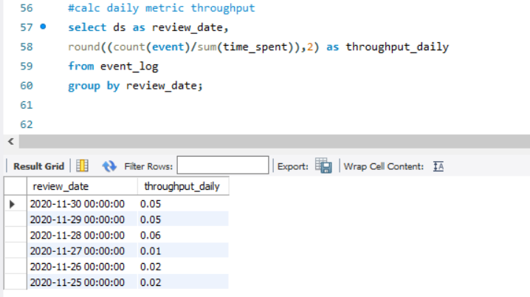

**c.Language Share Analysis:**

* + Objective: Calculate the percentage share of each language in the last 30 days.
  + Your Task: Write an SQL query to calculate the percentage share of each language over the last 30 days.

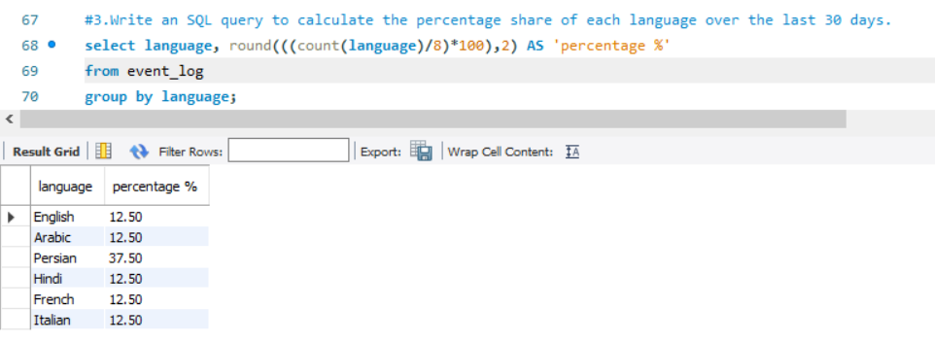

**D.Duplicate Rows Detection:**

* + Objective: Identify duplicate rows in the data.
  + Your Task: Write an SQL query to display duplicate rows from the job_data table.

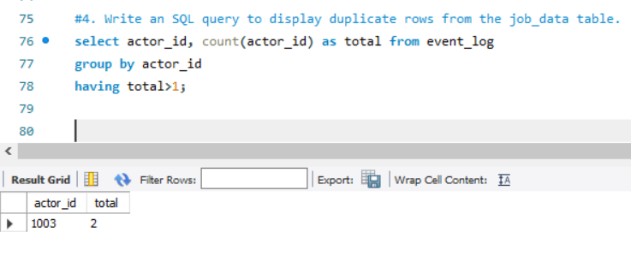

**Case Study 2: Investigating Metric Spike**

1. **Weekly User Engagement:**
   * Objective: Measure the activeness of users on a weekly basis.
   * Your Task: Write an SQL query to calculate the weekly user engagement.

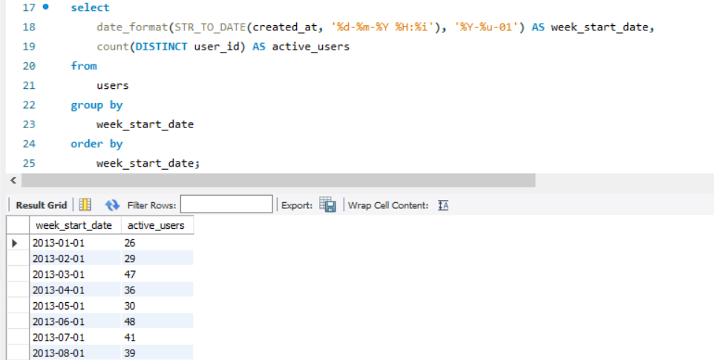

**B.User Growth Analysis:**

* + Objective: Analyze the growth of users over time for a product.
  + Your Task: Write an SQL query to calculate the user growth for the product.

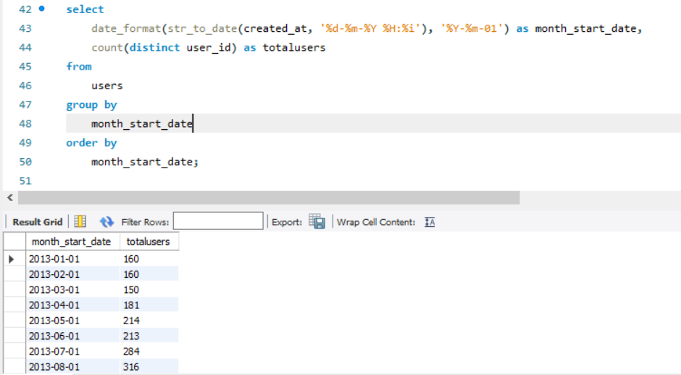

**C.Weekly Retention Analysis:**

* + Objective: Analyze the retention of users on a weekly basis after signing up for a product.
  + Your Task: Write an SQL query to calculate the weekly retention of users based on their sign-up cohort.

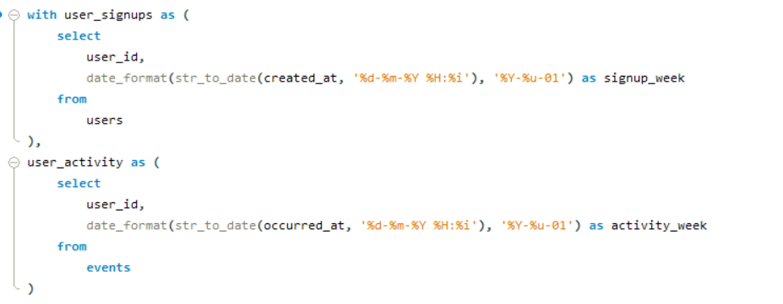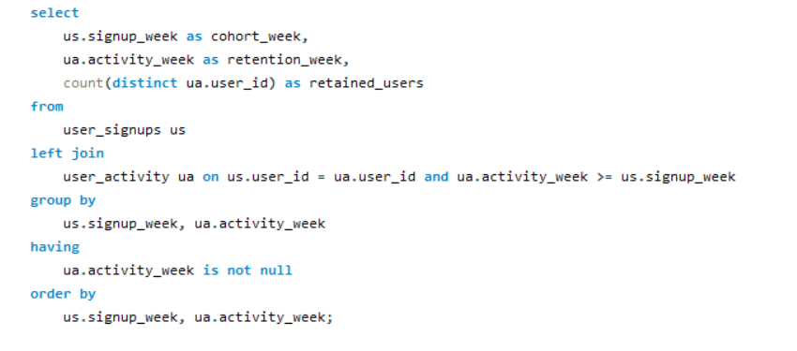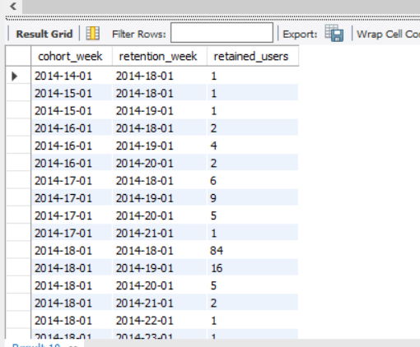

**E,Weekly Engagement Per Device:**

* + Objective: Measure the activeness of users on a weekly basis per device.
  + Your Task: Write an SQL query to calculate the weekly engagement per device.

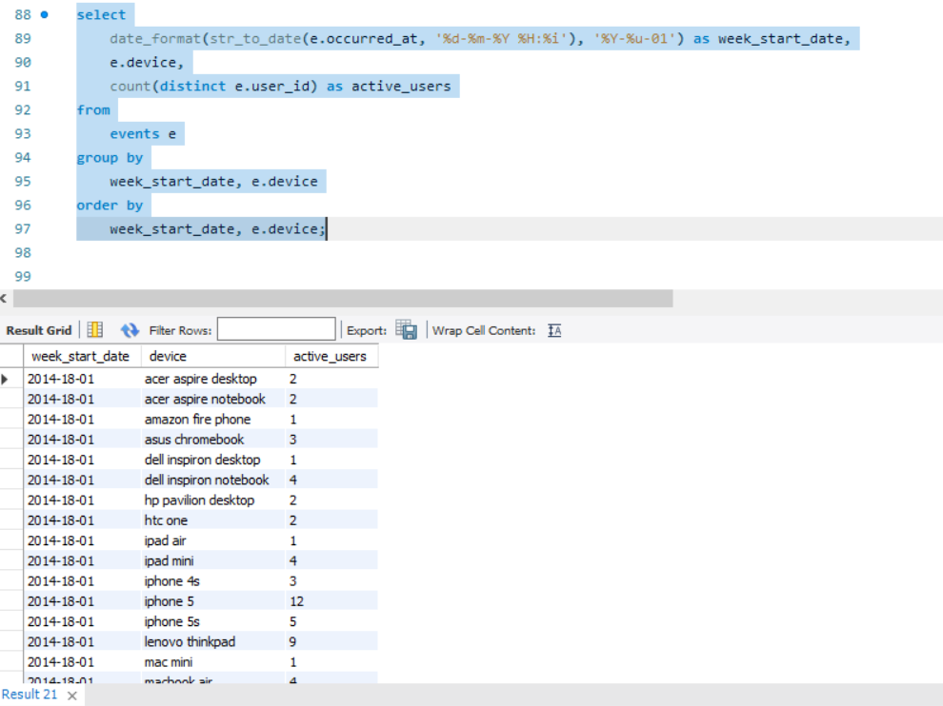

**E.Email Engagement Analysis:**

* + Objective: Analyze how users are engaging with the email service.
  + Your Task: Write an SQL query to calculate the email engagement metrics.

